**MUSIC STREAMING**

**RHYTHMIC TUNE**

1. **Introduction**
   * **Project Title**: Rhythmic Tune
   * **Team Members**:
     + Abinaya R
     + Afrin fathima A
     + Anandhi B
     + Anitha S

A rhythmic tune introduction for a music streaming platform could start with a catchy and smooth instrumental that draws the listener in right from the beginning. Imagine a blend of upbeat percussion, light synths, and rhythmic bass that feels both energetic and welcoming. The music could have a steady, toe-tapping beat, with subtle variations to keep it interesting, building anticipation as it leads into the main section of the track. The vibe would feel modern and fresh, setting the tone for the diverse music the platform offers. A short, memorable hook could be repeated a couple of times to create a recognizable theme, evoking a sense of familiarity every time the user starts streaming.

1. **Project Overview**
   * **Purpose**: The purpose of music streaming is to provide convenient, instant access to a vast library of music via the internet, without the need for physical media or downloads. It allows users to listen to their favorite songs, discover new artists, and create personalized playlists on-demand, often with features like recommendations based on listening habits. Music streaming also offers artists a platform to reach global audiences while generating revenue through subscriptions, advertisements, or a combination of both
   * **Features**: Music streaming services typically offer a variety of features to enhance the user experience. Some common features include:

1. On-Demand Playback: Access to a vast library of songs, albums, and playlists that can be played anytime, anywhere.

2. Personalized Recommendations: Services often use algorithms to suggest music based on listening history, preferences, and trends.

3. Playlists and Curated Content: Curated playlists, such as mood-based or genre-specific playlists, along with the option for users to create their own.

4. Offline Listening: Some services allow users to download music for offline listening, useful when there's no internet connection.

5. High-Quality Audio: Many platforms offer high-definition or lossless audio for audiophiles who want superior sound quality.

6. Cross-Device Sync: Seamless listening across multiple devices (smartphones, tablets, computers, smart speakers) while maintaining progress in playlists or albums.

7. Artist and Album Pages: Detailed pages for artists and albums, offering biographical information, discography, and other content.

8. Social Features: Ability to share music, playlists, or listening activity with friends or followers, and explore what others are listening to.

9. Radio and Live Streams: Features like personalized radio stations based on preferences or curated by the service, along with live streaming of concerts or events.

10. Podcasts and Additional Content: Many music streaming platforms also provide access to podcasts, interviews, and other non-music audio content.

11. Subscription Tiers*: Different levels of subscription, including free versions with ads and premium subscriptions offering additional features like ad-free listening, offline access, and more.

12. Integrated Voice Control: Integration with voice assistants (like Alexa, Google Assistant, or Siri) for hands-free control of music playback.

These features aim to make music discovery and enjoyment more accessible, personalized, and flexible.

1. **Architecture**

* **Component Structure**: The architecture of a music streaming system typically consists of several key components working together to deliver music content to users. Here's an overview of the architecture components and their structure:

1. Client Application (User Interface)

-Platform: The client app is the interface through which users interact with the music service. It can be available on multiple platforms like mobile devices (iOS, Android), desktops (Web, Windows, macOS), or smart speakers.

Components:

User Interface (UI): The visual elements (such as buttons, menus, and playlists) that users interact with.

User Authentication: Handles user login, sign-up, and session management (e.g., via OAuth, Firebase).

Playback Control: Manages music playback (play, pause, skip, etc.) and adjusts audio settings.

2. Backend Services (Server-Side)

API Layer: Provides the core business logic and interfaces for user requests, such as fetching song data, playlists, and recommendations. This layer communicates between the client application and the database/server.

RESTful APIs or GraphQL APIs are typically used for communication between the front-end and backend.

User Management: Handles user accounts, preferences, subscriptions, and history.

Music Content Management: Manages metadata about songs, albums, artists, and playlists. It handles the storage and retrieval of music content.

Recommendation Engine: Recommends new music based on user preferences, listening history, and patterns, typically using machine learning algorithms.

3. Music Database

Metadata Database: Stores detailed information about songs, albums, artists, playlists, genres, etc. This database could be relational (like MySQL, PostgreSQL) or NoSQL (like MongoDB).

Audio Content Storage: Music files (MP3, AAC, FLAC, etc.) are stored in cloud storage or a distributed file system. Services like Amazon S3, Google Cloud Storage, or dedicated CDN (Content Delivery Networks) are often used.

Caching Layer: Frequently accessed data, such as popular songs or playlists, are cached for faster retrieval, using technologies like Redis or Memcached.

4. Content Delivery Network (CDN)

CDN is crucial for ensuring fast and reliable delivery of music streams to users globally. It distributes copies of the music content across multiple servers in various geographic regions to reduce latency and improve streaming performance.

5. Streaming Server

Audio Streaming Service: The streaming server is responsible for delivering the audio content to users in real-time. This involves protocols such as **HLS* (HTTP Live Streaming) or DASH (Dynamic Adaptive Streaming over HTTP).

Adaptive Streaming: The server can adjust the quality of the stream based on the user's internet speed, delivering high-quality audio when possible and reducing quality during slower connections.

6.Authentication and Authorization Services

OAuth/OpenID Connect: Used for handling secure user logins (e.g., Google, Facebook login) and authorization.

Access Control: Manages permissions for accessing premium content, playlists, and user-specific features based on subscription tiers.

7. Analytics and Monitoring

User Behavior Analytics: Tracks user activities (listening patterns, skips, likes, etc.) to enhance recommendations and personalize the user experience.

Performance Monitoring: Ensures the platform is up and running, tracks server health, load balancing, and user experience metrics.

Content Analytics: Measures song popularity, tracks plays, skips, and likes to offer insights to artists and record labels.

8. Payment and Subscription Management

Payment Gateway Integration: Manages payments for subscriptions, including integration with payment processors (e.g., Stripe, PayPal).

Subscription Management: Handles subscription plans, renewals, upgrades, downgrades, and cancellations.

9. Push Notification and Messaging Service

Push Notifications: Notifies users of new content, playlist updates, artist news, or subscription reminders.

Email/Message Alerts: For transactional notifications such as billing updates, new releases, or activity summaries.

10. Third-Party Integrations

Social Media Integration: Allows users to share their activity, playlists, and songs on platforms like Facebook, Twitter, and Instagram.

Voice Assistants: Integration with Alexa, Google Assistant, and Siri for voice-controlled playback.

11. Security

Data Encryption: Ensures secure transmission of user data and audio content (e.g., using HTTPS, SSL/TLS).

Content Protection: Prevents piracy and unauthorized access to music using Digital Rights Management (DRM) technologies.

Example of Music Streaming Workflow:

1. User Request: The user opens the app and requests a song.

2. Authentication: If the user is logged in, their session is verified. If not, they are prompted to log in.

3. Data Retrieval: The backend fetches the song's metadata from the database and streams the audio content from the CDN.

4. Audio Streaming: The streaming server delivers the audio file, adjusting quality based on the user's internet connection.

5. Playback Control: The client application handles playback (pause, skip, volume control).

6. Recommendation Update: The system updates the user’s listening history and adjusts future recommendations based on this interaction.

This architecture ensures scalability, reliability, and seamless user experience by combining various backend services, databases, and distributed systems.**State**

**Management**: State management refers to the management of the state or data that represents the current condition or status of an application. In the context of a music streaming app, state management ensures that all parts of the app, such as the UI, user preferences, playlists, and audio playback, stay synchronized and reflect the correct data. Here's an overview of how state management works in such apps:

1. Client-Side State Management

On the client side (i.e., the user interface), state management typically includes the handling of:

Playback State: Information about the current song, play/pause status, volume level, current position in the track, etc.

User Preferences: Personalized settings like theme, language, playlists, and saved songs.

Authentication State: Whether the user is logged in, their user ID, and subscription tier (free, premium, etc.).

App Navigation State: Information about the user's current page, such as the home screen, playlist screen, or artist profile page.

Queue and Playlist State: The songs currently in the queue or a specific playlist.

Common strategies for managing state in a music streaming app (or any app) include:

Local State: This refers to the state stored directly within the components of the app. For example, React's useState or Angular's component-level state. This state is temporary and only persists as long as the user stays in the app.

Global State: For data that needs to be shared across multiple components (like user preferences or playback status), a global state management system is used. In JavaScript frameworks like React, libraries like Redux, Zustand, or Context API are often used to store this shared state globally.

2. Server-Side State Management

On the backend (server side), state management involves tracking and storing data that is not typically stored on the client device, such as:

User Profiles: Includes user account details, subscriptions, playlists, and listening history. This data needs to persist across sessions, so it's stored in databases.

Authentication State: The server handles user login sessions, access tokens, and authorization states.

Music Metadata: Keeps track of songs, albums, genres, and other metadata in a database.

Streaming State: On the backend, the server may need to manage aspects of streaming (like adaptive bitrate adjustments) and session data to handle playback.

The server-side state is typically managed through databases (SQL or NoSQL), caching solutions (like Redis), and session management systems.

3. State Management in a Music Streaming App - Example Workflow

Let's break down a typical state management flow in a music streaming app:

1. User Login:

- The user logs into the app (either via social login or credentials). The app sends an authentication request to the server.

- The server validates the credentials and returns an authentication token.

- The client stores this token locally (e.g., in secure storage) and updates the app's state to reflect the logged-in user.

2. Fetching Data:

- The app retrieves the user’s playlist, recommendations, and preferences from the server (using an API).

- The server returns the data, and the client updates its local state with this data.

3. Playback:

- The user presses play on a song. The app sends a request to the server to start streaming the song.

- As the song is streamed, the app maintains local state (e.g., current song, play/pause status) while also tracking position in the song.

- If the user skips a song, the state is updated to reflect the next song in the queue.

- The backend may adjust streaming quality based on the user's internet speed or other factors.

4. User Interaction:

- The user adds a song to their playlist or changes the volume. These actions update the client’s state (e.g., adding/removing songs from a playlist).

- The client syncs these changes with the server so that they persist across sessions.

5. Playlist Updates:

- If a user creates or modifies a playlist, the client updates its local state and also sends the changes to the server for persistence.

- The app may also synchronize playlists across multiple devices, maintaining consistency.

4. Popular Tools for State Management:

In various tech stacks, different tools and libraries are used to manage state effectively:

For Frontend (Client-Side):

Redux: A popular state management library for React applications that centralizes the state and helps to manage complex state interactions.

Context API (React): A simpler, built-in solution for sharing state across components without the complexity of Redux.

Zustand: A simpler state management library for React that focuses on minimalistic usage.

Vuex (Vue.js): A state management pattern and library for Vue.js applications.

NgRx (Angular): A state management library for Angular, inspired by Redux, that helps manage large-scale applications.

For Backend (Server-Side):

Databases: Data persistence is handled through relational (e.g., PostgreSQL, MySQL) or NoSQL (e.g., MongoDB, DynamoDB) databases, depending on the application's needs.

Session Management: Libraries such as Redis or JWT (JSON Web Tokens) are commonly used to store session data and manage authentication tokens.

Caching: Systems like RedisorMemcached help manage caching and speed up data retrieval, particularly for frequently accessed content like song metadata.

5. Challenges in State Management for Music Streaming

Consistency: Keeping the app’s state in sync across different devices or when switching between apps (e.g., switching from mobile to desktop).

Concurrency: Handling multiple actions simultaneously, such as a user playing a song on one device and skipping it on another.

Data Persistence: Ensuring that user data, preferences, playlists, and playback progress are preserved across sessions and devices.

In conclusion, effective state management in a music streaming app ensures a seamless and personalized user experience by carefully tracking, updating, and synchronizing the state across various components, devices, and services. This is achieved through a combination of client-side libraries and backend systems.**Routing**: Explain the routing structure if using react-router or another routing library.

1. **Setup Instructions**

**Prerequisites**: To start a music streaming service, there are several prerequisites you need to consider, including technical, legal, and business aspects. Here’s an outline of the key prerequisites:

**1. Licensing & Legal Requirements**

* **Music Licensing**: Securing the rights to stream music is essential. There are three primary types of licenses you’ll need:
  + **Mechanical License**: This grants permission to reproduce and distribute the music.
  + **Performance Rights License**: Required to publicly perform or stream the music.
  + **Synchronization License** (if using music in a video or commercial context).
* **Copyright Compliance**: Ensure all the music you're streaming is properly licensed, or you may face legal consequences.
* **Contracts with Record Labels and Artists**: Establish agreements with artists, record labels, and music publishers to stream their content.

**2. Technology & Infrastructure**

* **Streaming Platform**: You need a robust streaming platform to deliver music to users. This can either be developed in-house or purchased/licensed from third-party providers.
  + **Content Delivery Network (CDN)**: To ensure smooth streaming experiences, use a CDN to distribute music to users efficiently across different geographic locations.
* **Backend Infrastructure**: Secure and scalable servers to handle a large volume of music files, metadata, user accounts, and streaming requests.
* **Music Player Interface**: A well-designed user interface (UI) for web and mobile devices that allows users to search, browse, and play music seamlessly.
* **Data Security**: Protect users' data and ensure compliance with data protection regulations (e.g., GDPR).
* **Scalability**: You must be prepared to scale your infrastructure as your user base grows.

**3. Content**

* **Music Catalog**: You'll need a diverse and attractive catalog of music. This can be achieved through partnerships with record labels, independent artists, and aggregators who distribute music to streaming platforms.
* **Metadata Management**: Properly tagging and organizing the music catalog with metadata (song title, artist, album, genre, release date, etc.) to allow for efficient search and categorization.

**4. Monetization Model**

* **Subscription Model**: Offer premium, ad-free, or higher-quality streaming for a monthly fee (e.g., Spotify Premium).
* **Freemium Model**: Provide free access with ads or limitations, and charge for additional features (e.g., YouTube Music).
* **Advertisement**: Revenue from ads played during free-tier streams (e.g., Spotify free version).
* **Pay-Per-Stream or Download**: Charge users for individual songs or albums.

**5. User Experience (UX) Design**

* **Mobile App and Web Interface**: A smooth, intuitive, and responsive design is crucial. Users should be able to easily search for, listen to, and manage their music.
* **Personalized Recommendations**: Implement algorithms for music recommendations based on user behavior, preferences, and listening history.
* **Social Features**: Features like sharing playlists, following artists, and user-generated content can help engage users.

**6. Payment Systems**

* **Payment Gateway**: Integrate a secure and reliable payment gateway to handle user subscriptions, purchases, and other transactions.
* **Billing System**: Ensure you have a system in place to manage recurring payments, refunds, and account management.

**7. Marketing and Customer Acquisition**

* **Branding**: Develop a strong, recognizable brand with a unique selling proposition (USP).
* **User Acquisition Strategy**: Use social media marketing, influencer partnerships, targeted ads, and other strategies to attract new users.
* **Referral Program**: Offering incentives for users to refer others to the platform can help grow the user base.

**8. Analytics and Reporting**

* **User Analytics**: Collect and analyze data on user behavior, engagement, and demographics to optimize your service.
* **Music Analytics**: Track which songs, albums, or artists are most popular and how users are interacting with the content.
* **Performance Metrics**: Track streaming quality, downtime, and service performance to ensure a smooth user experience.

**9. Customer Support**

* **Help Desk**: Provide a responsive support system for users to report issues or get help with technical problems.
* **Community Engagement**: Engage with users through social media or other channels to build a loyal community.

**10. Compliance & Regulations**

* **Copyright and Fair Use**: Ensure compliance with international copyright laws and fair use policies.
* **Privacy Regulations**: Comply with privacy laws like GDPR, CCPA, and others relevant to the regions where you operate.

These are just some of the prerequisites for starting a music streaming service. Each of these areas requires careful planning and execution to ensure that your platform is successful and sustainable.

**Installation**: Installing a music streaming service can refer to either setting up the backend infrastructure and platform or setting up a local streaming system on your devices. If you're referring to creating a custom music streaming service or simply installing a music streaming app or platform, the process varies. Here’s a guide to both scenarios:

### 1. ****Installing a Music Streaming App (End-User Setup)****

If you want to install a music streaming app like Spotify, Apple Music, YouTube Music, or similar, here’s how you can do it:

#### For Mobile Devices (iOS/Android):

1. **App Store (iOS) or Google Play Store (Android):**
   * Open the app store on your device.
   * Search for the music streaming service (e.g., Spotify, Apple Music, YouTube Music).
   * Tap **Install** or **Get** to download and install the app.
   * After installation, open the app, create an account or log in, and start streaming music.

#### For Desktop (Windows/macOS):

1. **From the Website:**
   * Go to the official website of the music streaming service (e.g., [Spotify.com](https://www.spotify.com/), [Apple.com](https://www.apple.com/apple-music)).
   * Download the appropriate version of the desktop app for your OS (Windows or macOS).
   * Open the downloaded file to start the installation process.
   * Follow the on-screen instructions to install the software.
   * Once installed, open the app, log in, and begin streaming music.

#### For Web Browsers (Any Device):

1. **Web Player:**
   * Open your web browser (Chrome, Firefox, Safari, etc.).
   * Visit the official website of the streaming service (e.g., [Spotify Web Player](https://www.spotify.com/), [YouTube Music](https://music.youtube.com/)).
   * Log in or create an account to start streaming directly from the browser without needing to install an app.

### 2. ****Installing a Custom Music Streaming Server (Backend Setup)****

If you're building a **custom music streaming server** (for example, a personal music streaming system), here's a simplified version of how to set it up.

#### Prerequisites:

* A server or computer that can host the streaming software.
* Audio files you want to stream.
* Knowledge of networking, web servers, and music file formats.
* A domain name (optional) and/or an SSL certificate if you're setting it up for external access.

#### Example: Setting Up **Subsonic** (a popular open-source music streaming server)

##### **Step 1: Install Java**

Subsonic requires Java to run. Make sure you have Java installed on your server/computer.

* **For Ubuntu/Linux:**
* sudo apt update
* sudo apt install openjdk-11-jre
* **For macOS (Homebrew):**
* brew install openjdk@11

##### **Step 2: Download Subsonic**

1. Go to the official [Subsonic website](https://www.subsonic.org/).
2. Download the latest version of Subsonic (typically a .war file for Java-based installation).

##### **Step 3: Run Subsonic**

* **Linux/macOS**:
* java -jar subsonic-x.x.x.war
* **Windows**: Download the installer .exe file and follow the installation steps.

##### **Step 4: Configure the Music Library**

* Once Subsonic is running, open a web browser and visit http://localhost:4040 (or the IP address of the server if accessing remotely).
* You’ll be prompted to log in. The default login is:
  + Username: admin
  + Password: admin
* Navigate to the settings and configure your music library by pointing to the folder where your music files are stored.

##### **Step 5: Set Up Streaming**

* Make sure your music files are in a supported format (MP3, FLAC, etc.).
* Configure any extra settings, such as user accounts, streaming settings, and access controls.

##### **Step 6: Accessing the Stream**

* You can access the music library from any device on the same network by typing http://<your-server-ip>:4040 in a web browser.
* For external access, you can set up port forwarding on your router and use a domain name to access your streaming server from anywhere.

### 3. ****Alternative: Using Plex or Jellyfin for Music Streaming****

If you'd prefer a more user-friendly solution to create your own music streaming service, you can use platforms like **Plex** or **Jellyfin** that can serve both video and audio content.

#### Example: Setting Up **Plex**

1. **Install Plex Media Server:**
   * Go to the [Plex website](https://www.plex.tv/) and download the Plex Media Server installer for your operating system.
   * Install the server and follow the instructions to set up the Plex server on your machine.
2. **Add Music Library:**
   * Open the Plex web interface (http://localhost:32400/web), go to settings, and add your music folder.
3. **Access Music:**
   * Use the Plex app (available on mobile, desktop, smart TVs, etc.) to stream your music library from anywhere, as long as Plex is running on your server.

### Conclusion

* **For End Users**: Install apps like Spotify or Apple Music from official app stores or websites.
* **For Custom Servers**: Set up a personal music streaming server like Subsonic or Plex to stream your own music library across devices.

Let me know if you need help with any of these steps!.

1. **Folder Structure**

**Client**: If you're asking about **client-side music streaming**—i.e., how to implement or use a music streaming client (for playing music from a server or service on your device)—the process involves setting up the client software that allows users to stream music from a server, web-based service, or local media files.

Here’s a breakdown of what’s involved in **client-side music streaming**:

### 1. ****Using a Music Streaming App (Client Setup)****

This is the most common scenario where you’re using an established music streaming service like **Spotify, Apple Music, YouTube Music**, etc., to stream music on your device.

#### **Steps to Set Up a Music Streaming Client (App)**:

**For Mobile Devices (iOS/Android):**

1. **Download the App**:
   * Open the **App Store** (iOS) or **Google Play Store** (Android).
   * Search for the music streaming service you want (e.g., Spotify, Apple Music, Deezer).
   * Tap on **Install** or **Get** to download the app.
2. **Sign In or Create an Account**:
   * Open the app after installation.
   * Log in using your account credentials or sign up if you don’t have an account.
3. **Start Streaming**:
   * Browse or search for your desired music (artists, albums, genres, etc.).
   * Select the song/album you want to listen to and start streaming.

**For Desktop (Windows/macOS):**

1. **Download the Desktop App**:
   * Visit the official website of the music streaming service (e.g., Spotify, Apple Music).
   * Download the desktop version of the app (usually available as a .exe file for Windows or .dmg for macOS).
2. **Install and Log In**:
   * Install the app by running the downloaded installer.
   * Open the app and sign in using your credentials.
3. **Start Streaming**:
   * Browse and search for music and begin streaming directly on your computer.

**For Web (Browser-Based Streaming):**

1. **Open Web Player**:
   * Go to the web player of the streaming service (e.g., [Spotify Web Player](https://www.spotify.com/), [YouTube Music](https://music.youtube.com/)).
2. **Log In**:
   * Log in with your account credentials.
3. **Stream Music**:
   * Search for and play music directly from the web interface.

### 2. ****Creating a Custom Client for Music Streaming****

If you're building your own music streaming client (for example, to stream from a personal server or service), you need to implement several components, depending on the platform (mobile, desktop, or web). Below is a general guide on how to create a custom music streaming client:

#### **Components to Consider**:

1. **User Interface (UI)**:
   * Design a UI that allows users to search, browse, and play music. This can include:
     + Playlists
     + Album and song details
     + Search bar
     + Play/pause buttons, next/previous, volume control
     + Media controls
2. **Audio Playback**:
   * Implement audio playback functionality using audio libraries or APIs for the platform you’re building on.
   * For **web clients**, you can use HTML5 <audio> elements or JavaScript libraries (e.g., Howler.js).
   * For **mobile apps**, you can use libraries like **AVPlayer** (iOS) or **ExoPlayer** (Android).
   * For **desktop apps**, libraries like **VLC Media Player SDK** or **libVLC** can be used to handle audio playback.
3. **Server Communication**:
   * The client must communicate with the music server to retrieve the media.
   * Use **APIs** (such as RESTful APIs) to fetch music data (e.g., song titles, album art, track length) and stream audio data.
   * Consider the server’s response time and buffering methods to ensure smooth playback.
4. **Music File Formats**:
   * Decide which audio file formats you will support (MP3, AAC, FLAC, etc.). You need to ensure your client can decode and play these formats.
5. **Buffering and Caching**:
   * Implement buffering to prevent playback interruptions while the audio is loading.
   * Caching audio files or metadata can improve performance and allow offline playback.
6. **Authentication**:
   * If your service requires user accounts (e.g., to track playlists, favorites, etc.), you’ll need to implement a login system (OAuth, JWT tokens).
   * You can use social login systems (Google, Facebook) or a custom authentication system.
7. **Streaming Protocols**:
   * For real-time streaming, you may use protocols like **HTTP Live Streaming (HLS)** or **Dynamic Adaptive Streaming over HTTP (DASH)**.
   * These protocols allow adaptive bitrate streaming, adjusting quality based on the user's internet connection.
8. **Offline Mode (Optional)**:
   * Allow users to download songs or albums for offline listening.
   * This feature is common in premium versions of music streaming apps.

### 3. ****Example: Setting Up a Simple Music Streaming Client in HTML/JavaScript****

If you want to create a **web-based** client to stream music from a server, here's a simple example using HTML5 <audio> and JavaScript:

<!DOCTYPE html>

<html lang="en">

<head>

<meta charset="UTF-8">

<meta name="viewport" content="width=device-width, initial-scale=1.0">

<title>Music Streaming Client</title>

</head>

<body>

<h1>Music Streaming Client</h1>

<div id="player">

<audio id="audioPlayer" controls>

<source id="audioSource" src="your-audio-file.mp3" type="audio/mp3">

Your browser does not support the audio element.

</audio>

</div>

<div>

<button onclick="playMusic()">Play</button>

<button onclick="pauseMusic()">Pause</button>

<button onclick="nextTrack()">Next</button>

</div>

<script>

const audioPlayer = document.getElementById("audioPlayer");

const audioSource = document.getElementById("audioSource");

function playMusic() {

audioPlayer.play();

}

function pauseMusic() {

audioPlayer.pause();

}

function nextTrack() {

// Update the source with the next song URL

audioSource.src = "next-audio-file.mp3";

audioPlayer.load();

audioPlayer.play();

}

</script>

</body>

</html>

This example provides a simple audio player interface with play, pause, and next track functionality. The audio element is used to stream the music, and you can dynamically change the source URL to switch tracks.

### Conclusion:

* **For End Users**: Install an app or use a web-based client to stream music from a service like Spotify, Apple Music, or YouTube Music.
* **For Custom Streaming Clients**: Build a UI, implement audio playback, integrate with a music server, handle authentication, and manage music files.
* **For Web Clients**: Use HTML5 <audio> or JavaScript libraries to create your own player and fetch media from a server.

**Utilities**: Here’s a short list of useful utilities and tools that can enhance or help you with **music streaming**:

**1. Music Streaming Platforms:**

* **Spotify**: Popular music streaming service with millions of tracks, playlists, and podcasts.
* **Apple Music**: Provides a large catalog, with seamless integration for Apple users.
* **YouTube Music**: Music streaming service that integrates YouTube’s video library with music playback.
* **Deezer**: Offers a vast catalog and features such as HiFi audio streaming.
* **Tidal**: Known for high-fidelity sound quality and exclusive artist content.

**2. Streaming Servers:**

* **Plex**: Media server that allows you to stream your personal music collection to various devices.
* **Subsonic**: Open-source media server for streaming audio files and managing your music library.
* **Jellyfin**: Free, open-source media server similar to Plex, with audio and video streaming capabilities.

**3. Audio Player Libraries (for developers):**

* **Howler.js**: JavaScript library for modern web audio and music playback.
* **Audio.js**: A simple HTML5 audio player framework for web-based music streaming.
* **ExoPlayer**: Android media player for handling music playback in custom music apps.

**4. Music Downloader Tools (for personal use):**

* **4K Video Downloader**: A tool to download music and videos from YouTube and other platforms.
* **JDownloader**: An open-source tool for downloading audio and video from streaming sites.

**5. Music Recognition and Discovery:**

* **Shazam**: An app that identifies music tracks and provides direct access to streaming services.
* **SoundHound**: Another music recognition app with the ability to identify and play songs instantly.

**6. Playlist Management Tools:**

* **Soundiiz**: A tool to transfer playlists between different music streaming services.
* **Playlist Converter**: Converts playlists between platforms like Spotify, Apple Music, and Deezer.

These tools and services can help enhance your music streaming experience, whether you're consuming content, managing your own music library, or developing a custom music app..

1. **Running the Application**
   * Provide commands to start the frontend server locally.

**Frontend**: The **frontend** of a music streaming application is the part that users interact with directly. It’s the interface where they search for music, create playlists, and control playback. A well-designed frontend is crucial for providing a seamless and enjoyable user experience. Here’s an overview of the **frontend** components and considerations for a music streaming platform:

**Key Components of a Music Streaming Frontend**

1. **UI/UX Design**:
   * **Responsive Design**: Ensure the interface adapts to different screen sizes (desktop, tablet, mobile).
   * **User-Friendly Navigation**: Clear navigation through sections like Home, Search, Playlists, Artists, etc.
   * **Search Functionality**: Allow users to search by song, artist, album, or playlist.
   * **Now Playing Section**: Display the currently playing track, with options for play/pause, skip, volume control, etc.
   * **Visual Elements**: Display album artwork, artist images, and other relevant media.
2. **Audio Player Interface**:
   * **Play/Pause, Skip, Previous Track**: Basic controls for audio playback.
   * **Progress Bar**: To show the track’s progress and allow users to skip to specific parts of the song.
   * **Volume Control**: A slider to adjust audio levels.
   * **Track Information**: Display track name, artist, album, and duration.
   * **Shuffle/Repeat Buttons**: Options to shuffle tracks or repeat the current track/playlist.
3. **Playlist Management**:
   * **Create, Edit, and Delete Playlists**: Users should be able to manage their playlists.
   * **Add/Remove Songs**: Users can add songs to playlists or remove them.
   * **Drag and Drop**: For easy reordering of playlist tracks (optional feature).
4. **Search and Discovery**:
   * **Search Bar**: Quick access to find songs, albums, artists, and genres.
   * **Filters and Sorting**: Allow sorting by popularity, release date, genre, etc.
   * **Recommendations**: Personalized music recommendations based on the user’s listening history.
   * **Genre/Artist Pages**: Dedicated pages for exploring music by genre, artist, or album.
5. **User Account Management**:
   * **Login/Signup**: Implement user authentication for access to saved playlists and preferences.
   * **Profile Page**: Display user information, playlists, and listening history.
   * **Settings**: Preferences like notification settings, theme (dark/light mode), and connected accounts.
6. **Offline Mode**:
   * **Download Tracks**: Allow users to download songs for offline listening (premium feature).
   * **Manage Downloads**: A section to view and remove downloaded tracks.
7. **Notifications**:
   * **Alerts**: Notify users about new releases from favorite artists or upcoming concerts.
   * **Social Updates**: Show notifications about new followers or likes (if social features are integrated).
8. **Social Integration** (optional):
   * **Share Songs/Playlists**: Enable sharing to social media platforms (e.g., Twitter, Facebook, Instagram).
   * **Collaborative Playlists**: Allow multiple users to contribute to a playlist.
   * **Follow Artists/Users**: Users can follow other users or their favorite artists for updates.

**Tools and Technologies for Frontend Development**

1. **HTML5**: For building the structure of the web pages.
   * **Audio API**: The <audio> element can be used to embed audio files directly into the webpage for playback.
2. **CSS3**: For styling and creating a responsive design that works across devices.
   * **Flexbox/Grid**: For flexible and grid-based layouts.
   * **Media Queries**: For responsive design, ensuring the app looks good on desktops, tablets, and phones.
3. **JavaScript**: For interactivity and functionality.
   * **React**: A popular JavaScript library for building user interfaces. React is great for building interactive UIs and is widely used in modern frontend development.
   * **Vue.js**: Another JavaScript framework that’s easy to integrate and suitable for building single-page apps (SPAs).
   * **Angular**: A framework that provides a full set of tools to build complex applications.
4. **Audio Player Libraries**:
   * **Howler.js**: A JavaScript library for handling audio playback. It provides a simple API for controlling sound, including volume, loops, and multiple tracks.
   * **Tone.js**: A framework for creating interactive music in the browser. Good for handling more advanced audio features like synthesis and effects.
   * **React-Player**: A React component for embedding audio and video players, supporting features like playback control and media source integration.
5. **State Management**:
   * **Redux**: Often used with React to manage application state (e.g., currently playing song, user playlists).
   * **Context API**: A simpler alternative to Redux in React, useful for global state management.
6. **Backend Communication**:
   * **APIs**: For fetching music data (songs, albums, artists, etc.) from the backend or third-party music APIs (e.g., Spotify API, Apple Music API).
   * **RESTful APIs or GraphQL**: To interact with your backend server for user authentication, playlist management, and song retrieval.
   * **WebSocket**: For real-time communication if you have a live music feature or want to update the interface dynamically.
7. **Testing and Debugging**:
   * **Jest**: A JavaScript testing framework for unit and integration tests.
   * **React Testing Library**: For testing React components.
   * **Cypress**: For end-to-end testing to ensure the app works as expected.

**Example: Basic HTML5 Audio Player Code**

Here’s a simple example of an HTML5 audio player embedded in a webpage:

<!DOCTYPE html>

<html lang="en">

<head>

<meta charset="UTF-8">

<meta name="viewport" content="width=device-width, initial-scale=1.0">

<title>Music Streaming</title>

<style>

body { font-family: Arial, sans-serif; }

.audio-player { text-align: center; margin-top: 50px; }

.controls { display: flex; justify-content: center; gap: 20px; }

</style>

</head>

<body>

<div class="audio-player">

<h1>Now Playing</h1>

<audio id="audioPlayer" controls>

<source src="your-music-file.mp3" type="audio/mp3">

Your browser does not support the audio element.

</audio>

<div class="controls">

<button onclick="playPause()">Play/Pause</button>

<button onclick="nextTrack()">Next Track</button>

</div>

</div>

<script>

const audioPlayer = document.getElementById("audioPlayer");

function playPause() {

if (audioPlayer.paused) {

audioPlayer.play();

} else {

audioPlayer.pause();

}

}

function nextTrack() {

// Example: Change to another track

audioPlayer.src = "next-song.mp3"; // Change the track URL

audioPlayer.play();

}

</script>

</body>

</html>

This example provides a basic audio player with **Play/Pause** and **Next Track** functionality. You can easily expand this to include more features like shuffle, repeat, or advanced playlist management.

**Conclusion**

The frontend of a music streaming platform is key to user engagement. A well-structured, intuitive design with interactive features (search, playlist management, and playback controls) is essential for a positive user experience. Leveraging modern technologies like **React**, **Vue.js**, or **Angular**, and utilizing tools like **Howler.js** for audio management, helps streamline the development of a dynamic and responsive music streaming platform.

1. **Component Documentation**

**Key Components**: Here’s a **short list of key components** of a music streaming platform:

### 1. ****User Interface (UI)****

* **Navigation**: Easy-to-use menus to browse music (Home, Search, Playlists, Artists, etc.).
* **Now Playing Section**: Displays current song, artist, and album artwork with playback controls (play/pause, skip, volume).

### 2. ****Audio Player****

* **Playback Controls**: Play, pause, skip, rewind, volume control.
* **Progress Bar**: Track playback progress and allow skipping to specific parts of the song.

### 3. ****Search & Discovery****

* **Search Bar**: Find songs, albums, artists, or genres.
* **Recommendations**: Personalized suggestions based on listening history.

### 4. ****Playlist Management****

* **Create/Manage Playlists**: Add or remove songs from personal playlists.
* **Drag and Drop**: Easily reorder tracks in playlists.

### 5. ****User Account****

* **Sign-up/Sign-in**: User authentication to access saved playlists and preferences.
* **Profile Page**: Displays user’s playlists, favorites, and listening history.

### 6. ****Offline Mode**** (Premium Feature)

* **Download Music**: Save songs for offline listening.

### 7. ****Social Integration**** (Optional)

* **Share Songs**: Allow sharing via social media platforms.
* **Follow Artists/Users**: Follow favorite artists or users for updates.

These components make up the core of a music streaming platform, ensuring a smooth and engaging user experience.

**Reusable Components**: **Reusable Components** in a music streaming platform are modular elements that can be reused across different parts of the app to improve development efficiency and maintain consistency. Here are some key reusable components:

### 1. ****Audio Player****

* Controls for **play, pause, skip, volume**, and **track progress**.
* Displays **song title, artist**, and **album art**.
* Reusable across different screens (now playing, playlists, etc.).

### 2. ****Search Bar****

* A component for searching **songs, albums, artists, and playlists**.
* Can be reused in the navigation, homepage, and discovery sections.

### 3. ****Playlist Item****

* Displays a **song** or **playlist** with relevant details (name, artist, album art).
* Reusable in **search results**, **user profiles**, and **playlist management**.

### 4. ****Track List****

* A list of songs within a **playlist** or **album**.
* Reusable in **album pages**, **playlist pages**, and **search results**.

### 5. ****User Profile****

* Displays the user's **name**, **profile picture**, and **playlist** or **listening history**.
* Reusable in **account settings**, **profile page**, and **personalized recommendations**.

### 6. ****Song Card****

* A compact card showing **album art**, **song title**, and **artist name**.
* Reusable in **homepages**, **search results**, and **recommendation sections**.

### 7. ****Notification Badge****

* Displays notifications for **new releases**, **followed artists**, or **friend activities**.
* Reusable across the **header**, **settings**, and **activity feeds**.

These components are modular, easy to update, and help maintain consistency throughout the app. They make it simpler to develop and scale the music streaming platform.

1. **Styling**

**Theming**: **Theming** in a music streaming platform refers to the visual appearance, style, and design of the app. It ensures the user interface (UI) is visually appealing and provides a consistent experience across different devices. Theming includes aspects such as color schemes, fonts, icons, and layout styles. Here's an overview of **theming in music streaming platforms**:

**1. Color Scheme**

* **Primary Colors**: Choose colors that align with the brand identity. For example, Spotify uses green as its primary color.
* **Dark Mode/Light Mode**: Many platforms offer a **dark theme** (low-light environments) and a **light theme** (bright environments). Users can switch between them for a personalized experience.
* **Accent Colors**: Use accent colors to highlight important elements like buttons, notifications, and track progress bars.

**2. Typography**

* **Font Selection**: Choose fonts that are legible and on-brand (e.g., bold for headings, light for body text). For example, Apple Music uses **San Francisco**, and Spotify uses **Proxima Nova**.
* **Font Sizes**: Properly scale font sizes for readability across devices, especially for song titles, artist names, and descriptions.

**3. Icons & Visuals**

* **Iconography**: Use intuitive icons for actions like play, pause, skip, and shuffle. Make sure they are clear and easy to understand.
* **Album Artwork**: Display high-quality album art to enhance the visual experience and give users a better sense of the content they are consuming.

**4. Layout & Spacing**

* **Responsive Design**: Ensure the app looks great on various screen sizes (smartphones, tablets, and desktops).
* **Grid vs. List Layout**: Depending on the section, use grid layouts (for albums, playlists) or list layouts (for tracklists, recommendations).
* **Spacing**: Proper use of whitespace to avoid a cluttered UI. It’s important for easy navigation and to focus user attention.

**5. Customizable Themes**

* **User Personalization**: Allow users to select their preferred theme or color palette. Some platforms let users choose a custom accent color, while others provide a range of preset themes.

**6. Animations & Transitions**

* **Smooth Animations**: Use subtle animations for transitions, like when switching between tracks or moving between pages. This adds to the user experience without being distracting.
* **Loading States**: Use animated loaders or skeleton screens while content (like songs or playlists) is loading.

**7. Branding**

* **Logo**: Display your platform's logo consistently across the app.
* **Brand Elements**: Integrate specific branding elements (like unique button styles or color variations) that align with the company’s identity.

**Example of Theming Implementation:**

In **React**, you can implement theming by using CSS variables or theme context. Here’s a simple implementation for **Dark Mode/Light Mode** toggle:

import React, { useState } from 'react';

import './App.css';

function App() {

const [isDarkMode, setIsDarkMode] = useState(false);

const toggleTheme = () => {

setIsDarkMode(!isDarkMode);

};

return (

<div className={isDarkMode ? 'dark-mode' : 'light-mode'}>

<header>

<button onClick={toggleTheme}>

Toggle {isDarkMode ? 'Light' : 'Dark'} Mode

</button>

</header>

<main>

<h1>Welcome to Music Streaming!</h1>

{/* Music content here */}

</main>

</div>

);

}

export default App;

In **CSS**:

/* Light mode */

.light-mode {

background-color: #fff;

color: #000;

}

/* Dark mode */

.dark-mode {

background-color: #121212;

color: #fff;

}

button {

background-color: #00c853;

color: white;

padding: 10px 20px;

border: none;

cursor: pointer;

}

**Conclusion**

Theming in a music streaming platform is not just about colors and fonts, but also about creating an immersive and user-friendly experience. Whether through dark/light modes, personalized themes, or brand-centric elements, theming plays a crucial role in making the app visually appealing and comfortable for users across different devices and environments.

1. **Testing**

**Testing Strategy**: A **Testing Strategy** for a music streaming platform ensures the app functions smoothly and delivers a seamless user experience. Here's a concise overview of a typical testing approach:

### 1. ****Unit Testing****

* **Purpose**: Test individual components and functions (e.g., audio player controls, playlist management).
* **Tools**: **Jest**, **Mocha**, or **Chai** for JavaScript-based testing.
* **Focus**: Ensure each piece of code works correctly in isolation.

### 2. ****Integration Testing****

* **Purpose**: Ensure different parts of the application work together (e.g., search functionality interacting with the API).
* **Tools**: **Jest**, **Cypress**, or **TestCafe** for testing interactions between components.
* **Focus**: Check the data flow between components like the frontend and backend.

### 3. ****End-to-End (E2E) Testing****

* **Purpose**: Simulate real user interactions and test the entire workflow (e.g., playing a song, creating a playlist).
* **Tools**: **Cypress**, **Selenium**, or **Puppeteer**.
* **Focus**: Test user journeys from logging in to listening to music and managing playlists.

### 4. ****Performance Testing****

* **Purpose**: Test how the platform handles different loads (e.g., multiple users streaming at once).
* **Tools**: **JMeter**, **LoadRunner**, or **K6**.
* **Focus**: Evaluate streaming speed, app responsiveness, and scalability under various conditions.

### 5. ****Usability Testing****

* **Purpose**: Ensure the app is easy to use and intuitive.
* **Methods**: **User testing**, **A/B testing**, or **surveys**.
* **Focus**: Gather feedback from real users on interface design, navigation, and overall experience.

### 6. ****Security Testing****

* **Purpose**: Test for vulnerabilities in user authentication, data storage, and music streaming.
* **Tools**: **OWASP ZAP**, **Burp Suite**.
* **Focus**: Protect user data, prevent unauthorized access, and ensure secure payments.

### 7. ****Cross-Platform Testing****

* **Purpose**: Ensure compatibility across different devices (iOS, Android, web) and browsers.
* **Tools**: **BrowserStack**, **Sauce Labs**.
* **Focus**: Test that the platform works seamlessly across various platforms and screen sizes.

### Conclusion

A comprehensive **Testing Strategy** ensures that the music streaming platform is functional, performant, secure, and user-friendly across different environments and user scenarios. By combining unit, integration, E2E, and performance testing, the app can deliver a reliable experience to its users.

1. **Screenshots or Demo**

* Provide screenshots or a link to a demo showcasing the application’s features and design.
* **Music Streaming HTML Code**

<!DOCTYPE html>

<html lang="en">

<head>

<meta charset="UTF-8">

<meta name="viewport" content="width=device-width, initial-scale=1.0">

<title>Spotify-Inspired Music App</title>

<style>

@import url('https://fonts.googleapis.com/css2?family=Poppins:wght@300;400;600&display=swap');

* {

margin: 0;

padding: 0;

box-sizing: border-box;

font-family: 'Poppins', sans-serif;

}

body {

background: linear-gradient(to right, #A8E063, #388E3C); /* Light green to dark green gradient */

color: white;

display: flex;

justify-content: center;

align-items: center;

height: 100vh;

overflow: hidden;

padding: 20px;

}

.container {

width: 90%;

max-width: 1000px;

text-align: center;

height: 90vh;

display: flex;

flex-direction: column;

}

h2 {

font-size: 28px;

font-weight: 600;

margin-bottom: 10px;

background: linear-gradient(to right, #A8E063, #388E3C); /* green gradient */

padding: 10px 0;

z-index: 10;

}

h3 {

font-size: 20px;

font-weight: 400;

margin-bottom: 15px;

opacity: 0.9;

}

.grid-container {

flex-grow: 1;

overflow-y: auto;

padding-right: 10px;

}

.grid {

display: grid;

grid-template-columns: repeat(3, 1fr);

gap: 20px;

padding: 20px;

}

.song {

background: rgba(255, 255, 255, 0.1);

padding: 12px;

border-radius: 12px;

text-align: center;

cursor: pointer;

transition: transform 0.3s ease, background 0.3s ease;

}

.song:hover {

transform: scale(1.05);

background: rgba(255, 255, 255, 0.2);

}

.song p {

margin: 6px 0;

color: #fff;

}

.song .title {

font-size: 15px;

font-weight: 600;

}

.song .details {

font-size: 12px;

font-weight: 300;

opacity: 0.9;

}

.audio-player {

margin-top: 20px;

}

</style>

</head>

<body>

<div class="container">

<h2>🎵 Trendy Tamil Tunes 🎶</h2>

<h3>🎧 Play Your Favorite Songs 🎧</h3>

<div class="grid-container">

<div class="grid">

<!-- Song 1 -->

<div class="song" onclick="playSong('Apdi Podu')">

<p class="title">Apdi Podu</p>

<p class="details">Song Name: Apdi Podu<br>Movie Name: Ghilli</p>

</div>

<!-- Song 2 -->

<div class="song" onclick="playSong('Alaporan')">

<p class="title">Alaporan Tamilzhan</p>

<p class="details">Song Name: Alaporan Tamilzhan<br>Movie Name: Mersal</p>

</div>

<!-- Song 3 -->

<div class="song" onclick="playSong('NeeDhaney')">

<p class="title">Nee Dhaney</p>

<p class="details">Song Name: Nee Dhaney<br>Movie Name: Mersal</p>

</div>

<!-- Song 4 -->

<div class="song" onclick="playSong('Venilavusaaral')">

<p class="title">Venilavusaaral</p>

<p class="details">Song Name: Venilavusaaral<br>Movie Name: Amaran</p>

</div>

<!-- Song 5 -->

<div class="song" onclick="playSong('Mehabooba')">

<p class="title">Mehabooba</p>

<p class="details">Song Name: Mehabooba<br>Movie Name: KGF</p>

</div>

<!-- Song 6 -->

<div class="song" onclick="playSong('AllIsWell')">

<p class="title">All Is Well</p>

<p class="details">Song Name: All Is Well<br>Movie Name: Nanban</p>

</div>

<!-- Song 7 -->

<div class="song" onclick="playSong('AskuLaska')">

<p class="title">Asku Laska</p>

<p class="details">Song Name: Asku Laska<br>Movie Name: Nanban</p>

</div>

<!-- Song 8 -->

<div class="song" onclick="playSong('GoldenSparow')">

<p class="title">Golden Sparow</p>

<p class="details">Song Name: Golden Sparow<br>Movie Name: NEEK</p>

</div>

<!-- Song 9 -->

<div class="song" onclick="playSong('Sawadeeka')">

<p class="title">Sawadeeka</p>

<p class="details">Song Name: Sawadeeka<br>Movie Name: Vidamuyarchi</p>

</div>

<!-- Song 10 -->

<div class="song" onclick="playSong('Peelings')">

<p class="title">Peelings</p>

<p class="details">Song Name: Peelings<br>Movie Name: Pushpa 2</p>

</div>

</div>

</div>

<div class="audio-player">

<audio id="audio-player" controls>

<source id="audio-source" src="" type="audio/mp3">

Your browser does not support the audio element.

</audio>

</div>

</div>

<script>

function playSong(song) {

const audio = document.getElementById('audio-player');

const audioSource = document.getElementById('audio-source');

// Set the audio source to the selected song

const songFile = `${song}.mp3`; // Assuming MP3 files are named like songname.mp3

// Set the audio source to the selected song file

audioSource.src = songFile;

audio.load(); // Load the new audio file

audio.play(); // Play the song

}

</script>

</body>

</html>

* 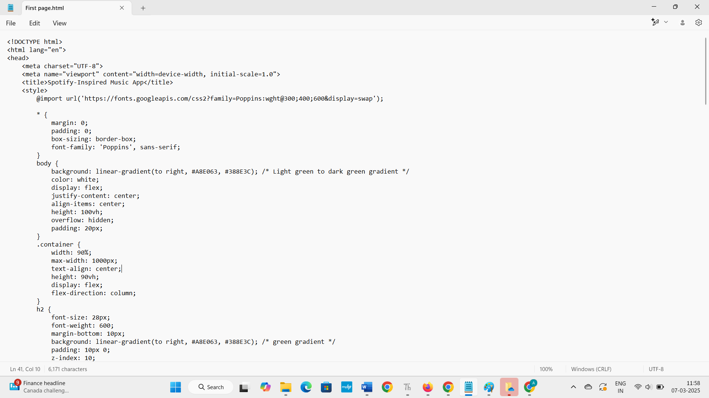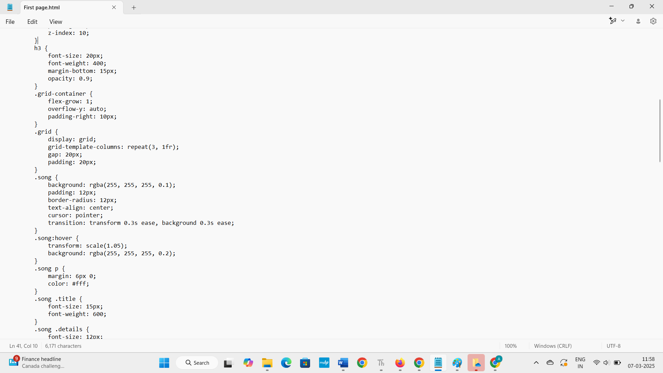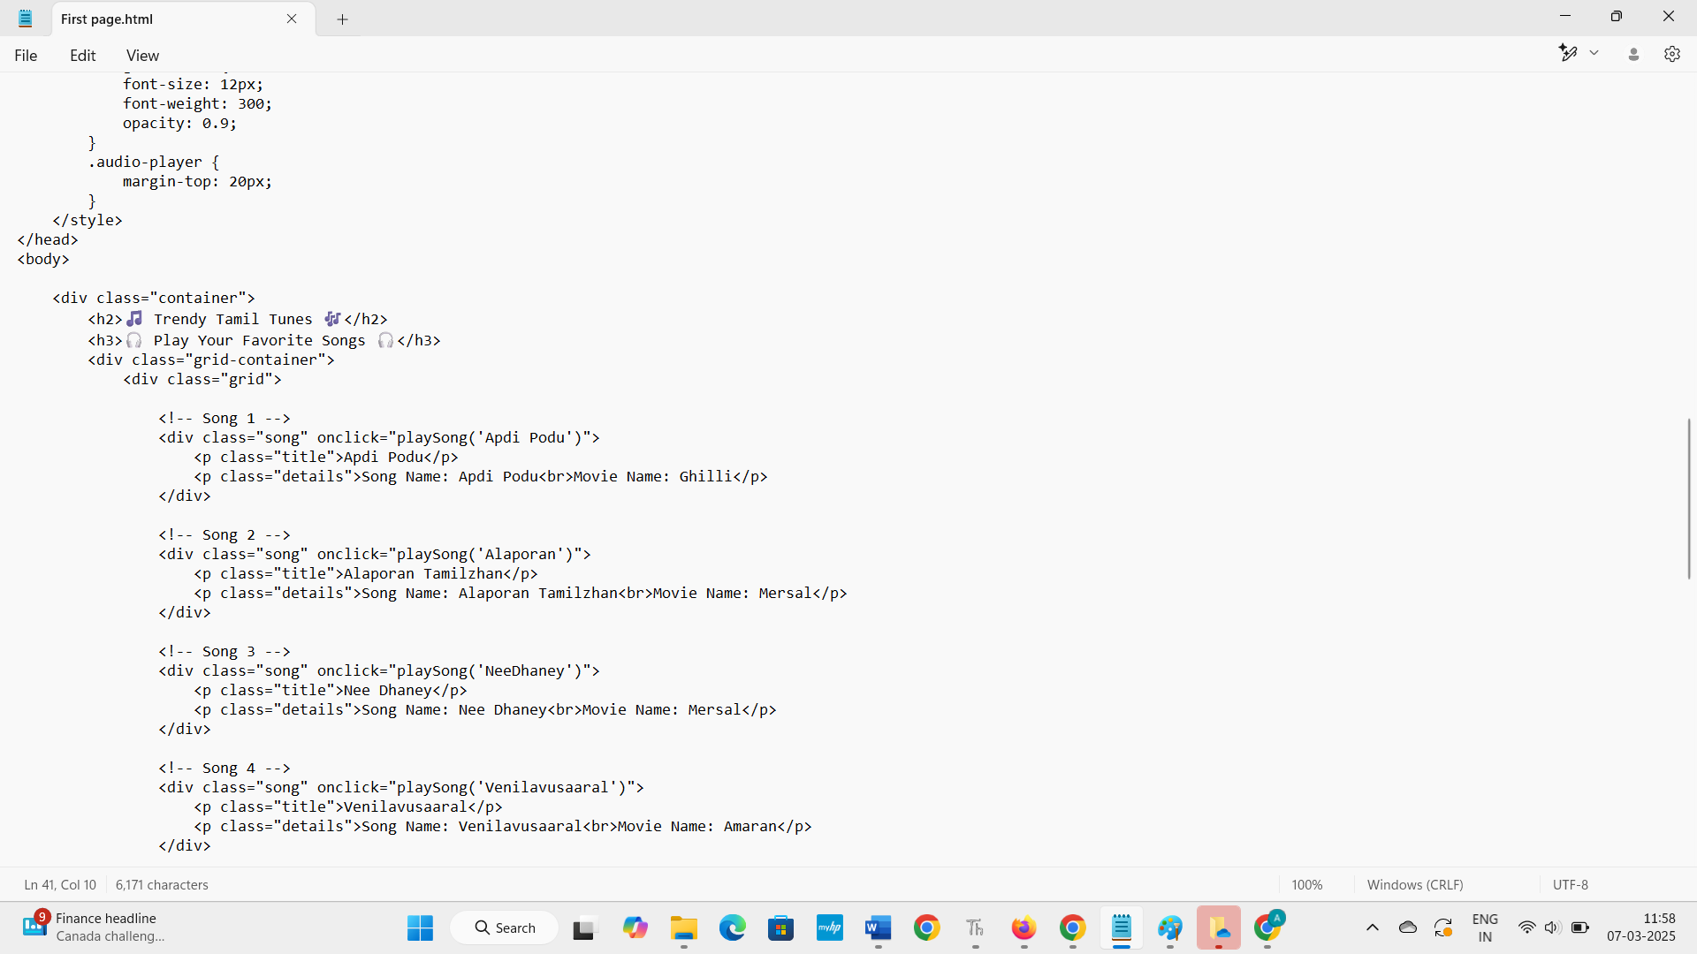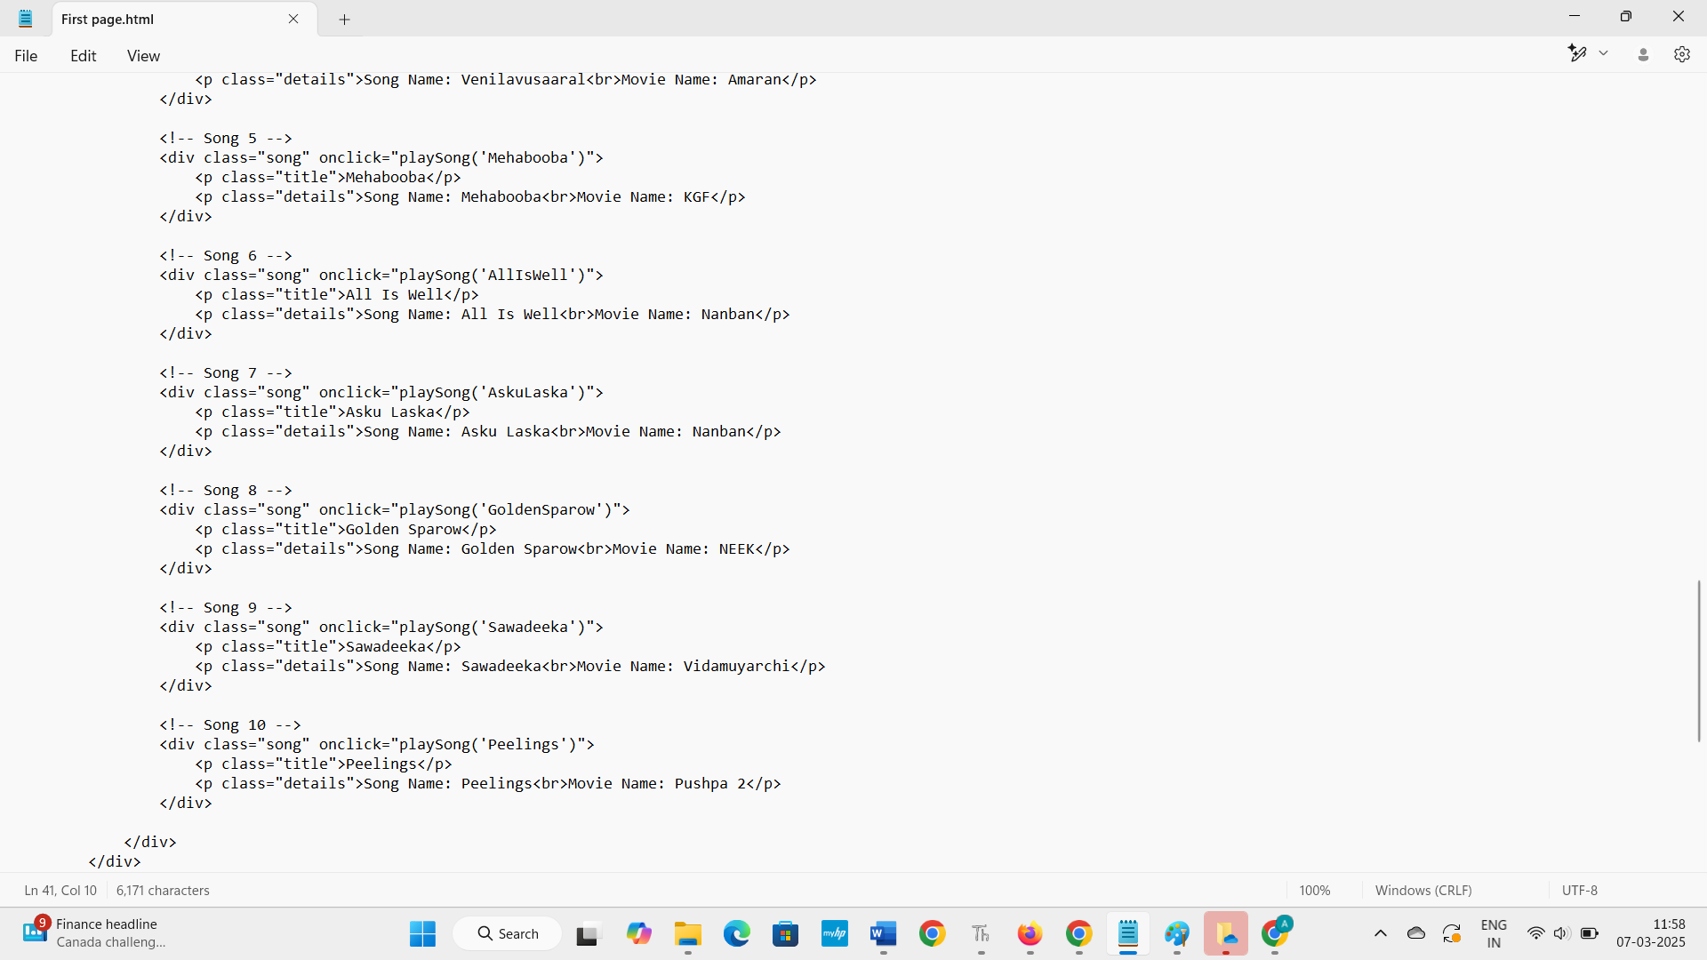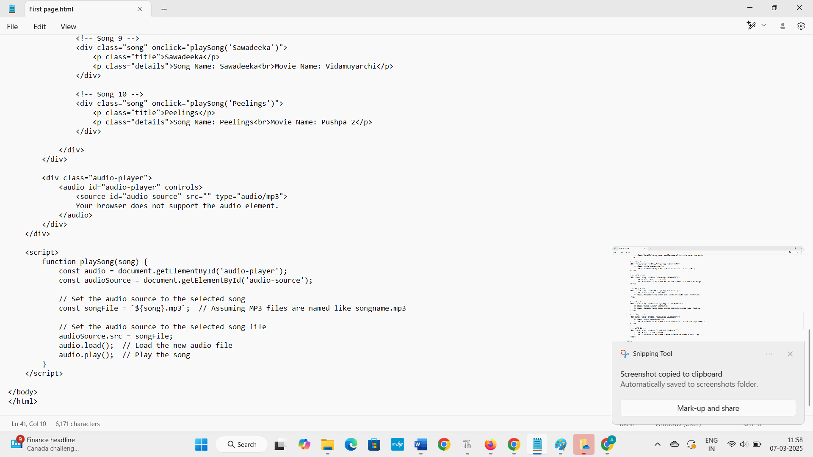
* **TO RUN THE PROGRAM:** 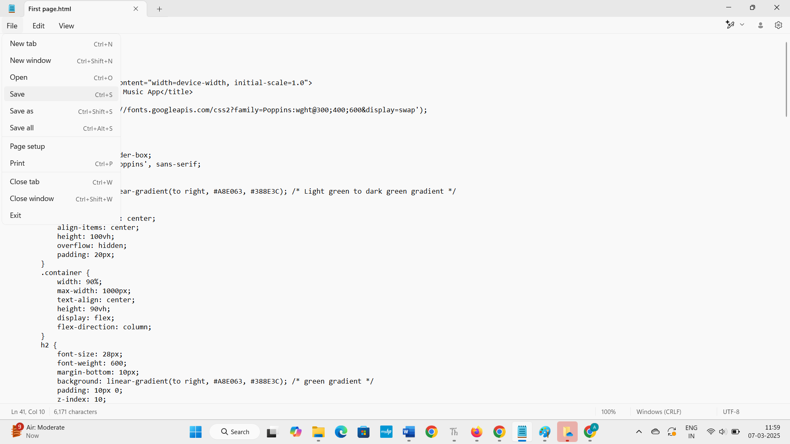
* 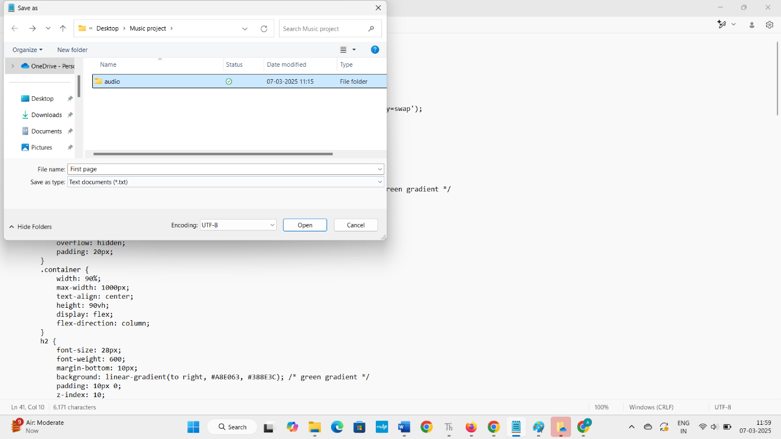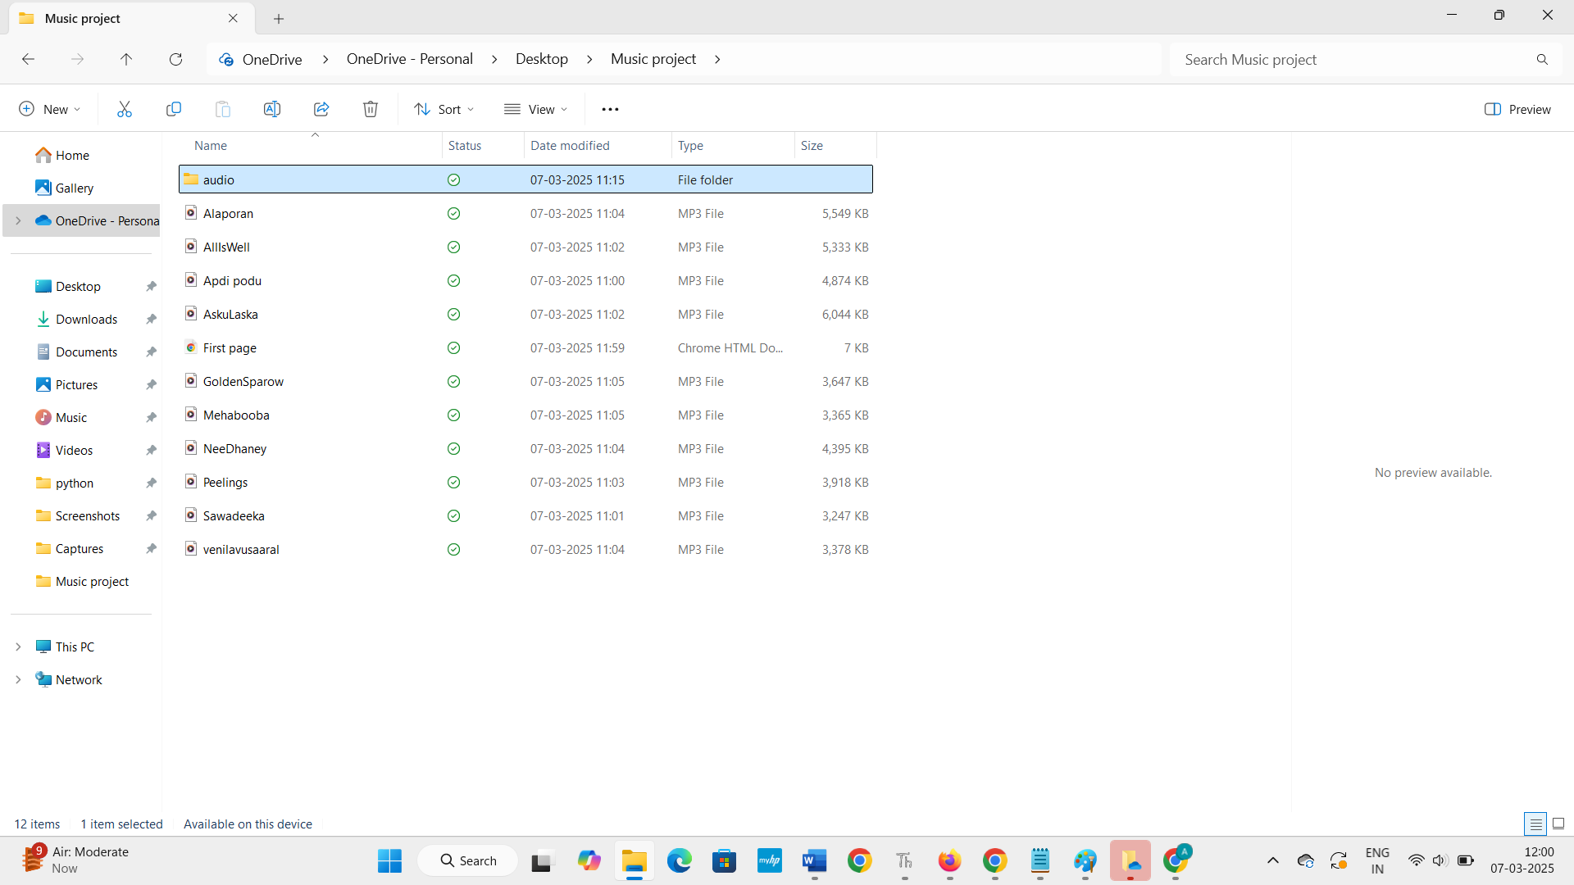
* 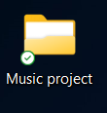

1. **Known Issues**

Here’s a short list of **known issues** that can arise in a **music streaming platform**:

**1. Audio Playback Issues**

* **Buffering/Slow Streaming**: Poor internet connection or server overload can cause audio to buffer or pause.
* **Audio Sync Problems**: Mismatched audio and video in music videos or during live streaming events.

**2. Search Functionality**

* **Incorrect Results**: Search may return irrelevant or incomplete results for songs, artists, or albums.
* **Misspelled Queries**: Failure to handle search queries with minor spelling errors.

**3. Playback Controls**

* **Unresponsive Controls**: Play/pause, skip, or volume buttons may not function properly.
* **Track Progress Errors**: The progress bar may not update correctly, showing inaccurate playback progress.

**4. Offline Mode Problems**

* **Download Failures**: Songs may fail to download for offline listening, or downloaded music may be inaccessible.
* **Sync Issues**: Offline data not syncing properly when the user reconnects to the internet.

**5. Device Compatibility**

* **App Crashes on Certain Devices**: Some devices (especially older models) may struggle to run the app smoothly.
* **Cross-Platform Sync Issues**: Inconsistent syncing between devices (e.g., mobile, desktop) for playlists or listening history.

**6. Subscription & Payment Issues**

* **Subscription Errors**: Users may face issues with upgrading or renewing subscriptions, including payment failures.
* **Access Problems**: Users may lose access to premium features after successful payments.

**7. Performance Issues**

* **Slow Load Times**: Slow loading of playlists, album artwork, or track data.
* **Lagging UI**: UI elements or transitions may lag or freeze, particularly during heavy usage.

**8. Audio Quality**

* **Low-Quality Streams**: Some users may experience poor audio quality due to streaming settings or bandwidth limitations.
* **Distorted Sound**: Occasional distortion or skipping during playback, particularly on mobile devices or poor internet connections.

These **known issues** can vary depending on the platform, device, or user settings, and often require troubleshooting or updates to fix.

**Conclusion about Music Streaming**:

Music streaming has revolutionized the way we consume music, offering convenience, vast catalogs, and personalized experiences. With platforms like Spotify, Apple Music, and YouTube Music, users can access millions of songs anytime, anywhere, and on any device. The **frontend** of music streaming apps must prioritize ease of navigation, responsive design, and user engagement, while **backend** systems ensure smooth streaming, secure data management, and integration with music libraries.

Key components such as **audio players**, **playlists**, and **search features** are essential for a seamless experience. Additionally, **theming**, **testing strategies**, and addressing **known issues** ensure that apps provide both visual appeal and functionality. However, challenges like buffering, device compatibility, and performance issues still persist and require constant attention.

Overall, **music streaming platforms** continue to evolve with advanced features like offline listening, social integration, and high-quality audio, all contributing to a rich, interactive experience that transforms how we enjoy and discover music.